

University of Ljubljana  
 Faculty of Computer and Information Science

**SEMINAR 2**

Derive STFT of women and man sound record

**Subject:** Digital signal processing Ljubljana, januar 2021

**Author:** Timotej Tim Rus, 63180256

Table of Contents

1. Introduction 3

2. Methods 3

3. Result 4

4. Discussion 6

# Introduction

**Derive Short Term Fourier Transform (STFT) of woman’s and man’s sound record**

The two vocal properties are intensity (loudness) and frequency (pitch). Pitch of a man’s voice fall under low frequency, where as woman’s voice is of the high pitch type. Pitch and intensity are proportional to each other

# Methods

Task1: Calculate and show the STFT of each record.

First I used audioread Matlab function to read each .wav file. [y,Fs] = audioread('filename') reads data from the file named filename – which is in our case .wav file, and returns sampled data, y, and a sample rate for that data, Fs.

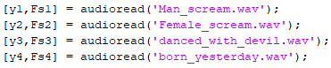

I tried and played them all with function sound(y, Fs).



After that, we need to calculate and show STFT of each .wav file.

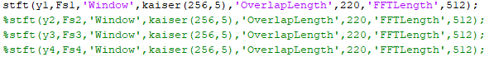

I set Kaiser window to length 256 and add shape parameter *β*=5. I specified the length of overlap as 220 samples and DFT length as 512 points.

# Result

Result of the Man_scream.wav file:

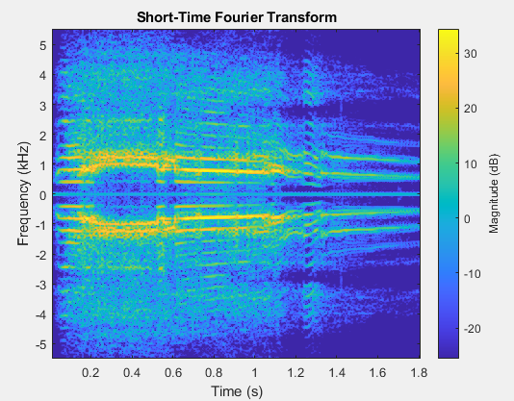

Result of the Woman_scream.wav file:

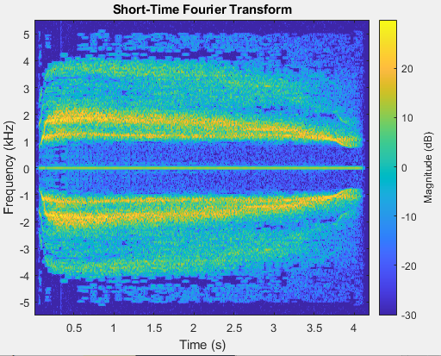

Result of the danced_with_devil.wav:

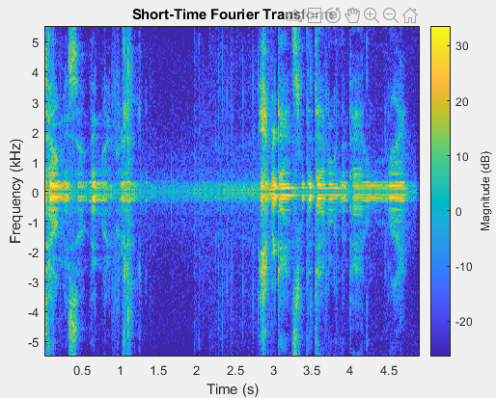

Result of the born_yesterday.wav:

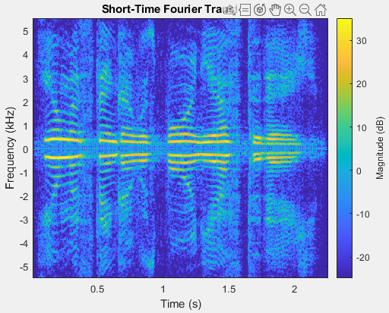

# Discussion

Women have higher pitch than men, but the frequency is approximately the same.

Comparison between those two voices is on the picture below.

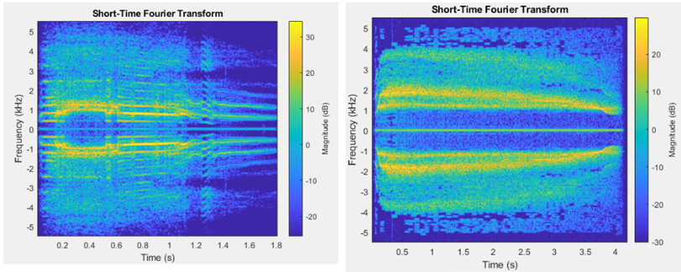

Man voice Woman voice